8. Using the CPU-OS simulator analyse and synthesize the following: a. Process Scheduling algorithms. b. Thread creation and synchronization. c. Deadlock prevention and avoidance.

1. Download the YASS simulator from the link:
http://www.teach-sim.com
- Install the simulator , when you run the simulator the following screen appears:
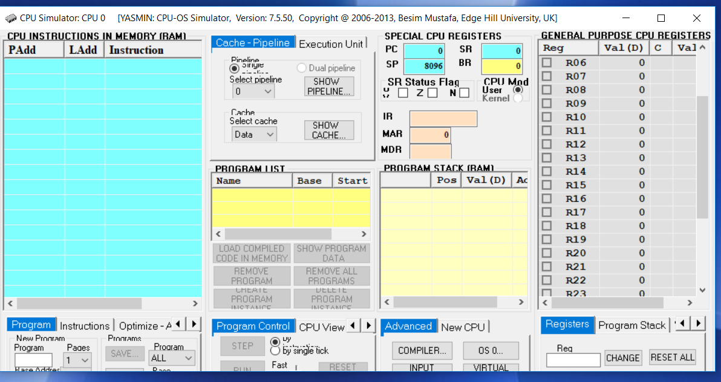

Experiment 1 Process scheduling: Follow the steps as given in the link //www.teachsim.com/Operating systems-Investigating process scheduling.
Step1 :Entering source code in the compiler and compiling it to an executable program.
  - You need to create some executable code so that it can be run by the CPU simulator under the control of the OS simulator. In order to create this code, you need to use the compiler which is part of the system simulator. This compiler is able to compile simple high-level source statements similar to Visual Basic. To do this, open the compiler window by selecting the COMPILER… button in the current window. You should now be looking at the compiler window.

  - In the compiler window, enter the following source code in the compiler’s source editor window (under PROGRAM SOURCE frame title) as shown in the screen shot:

program LoopTest i = 0 for n = 0 to 40 i = i + 1 next end

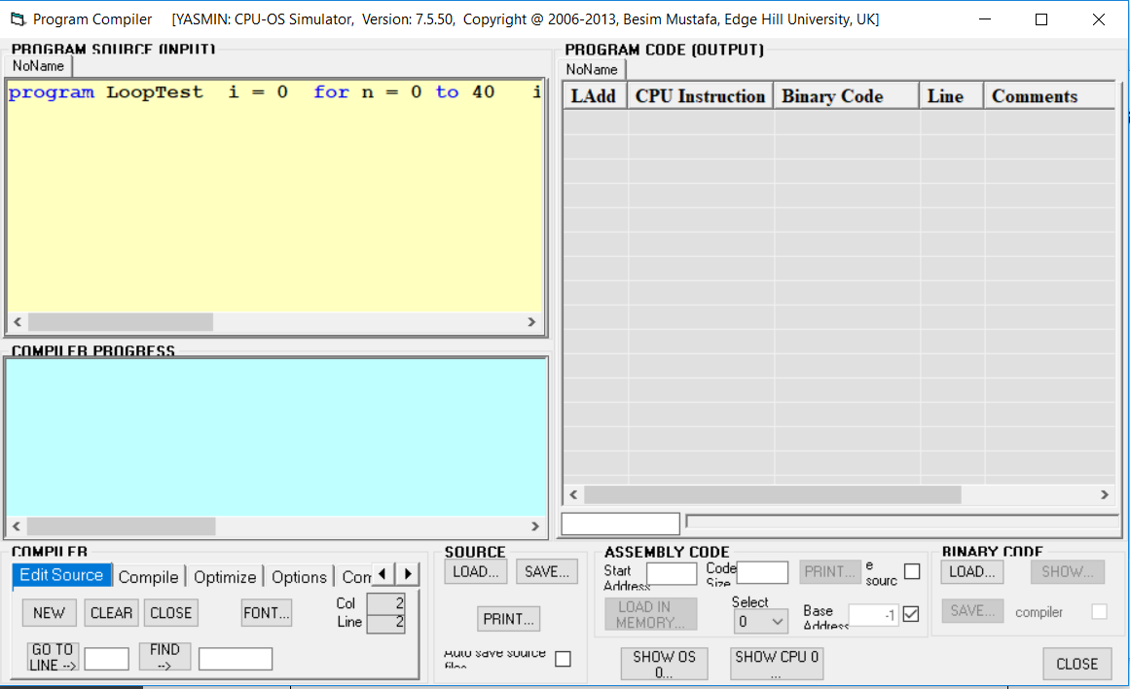

  - Now you need to compile this in order to generate the executable code. To do this, click on the COMPILE… button. You should see the code created on the right in PROGRAM CODE view. Make a habit of saving your source code. The code is shown below:
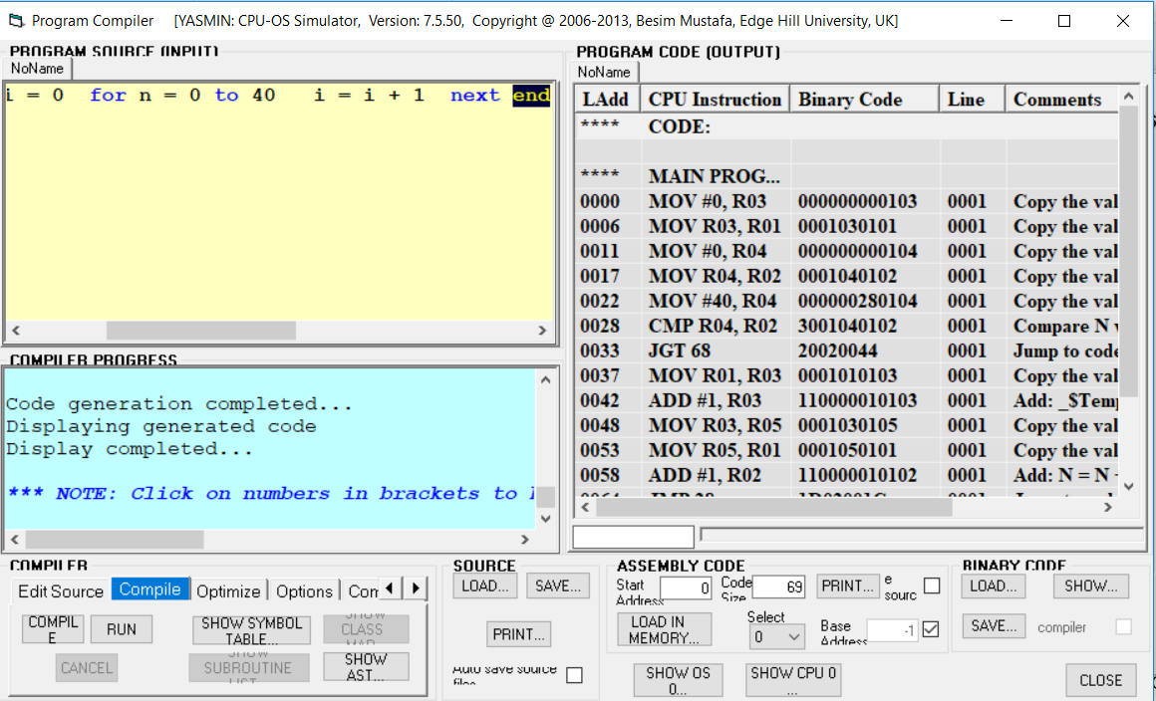

  - Click on the button SHOW… in BINARY CODE view as indicated by an arrow in the above figure. You should now see the Binary Code for LOOPTEST window.
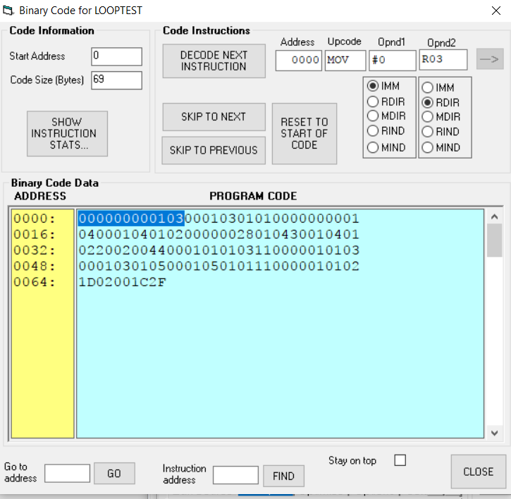

Step 2: Loading the program into the CPU simulator’s memory.
Now, this code needs to be loaded in memory so that the CPU can execute it. To do this, first we need to specify a base address (in ASSEMBLY CODE view): uncheck the box next to the edit box with label Base Address, and then enter 100 in the edit box. Now, click on the LOAD IN MEMORY… button in the current window. You should now see the code loaded in memory ready to be executed. You are also back in the CPU simulator at this stage. This action is equivalent to loading the program code normally stored on a disc drive into RAM on the real computer systems.

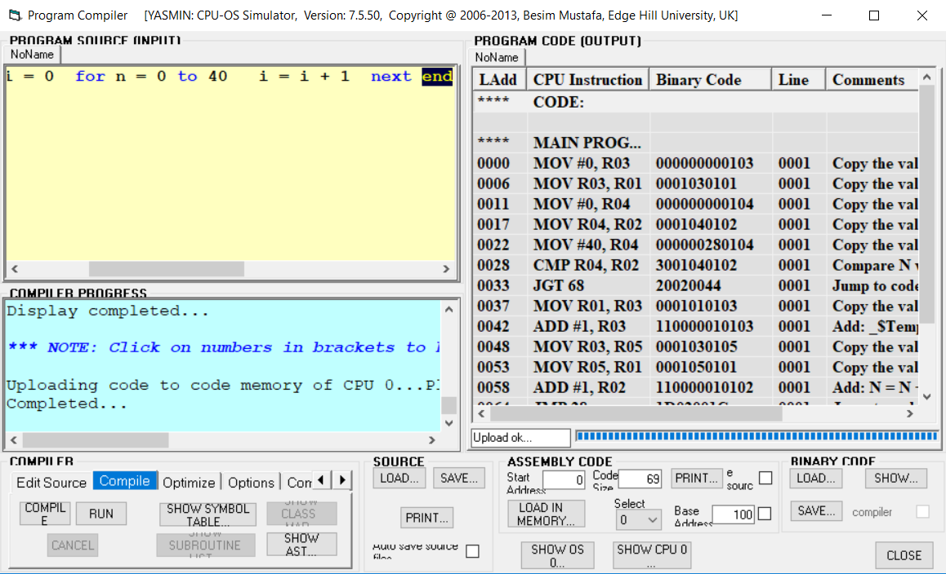

Step3: Create processes from programs in the OS simulator.
We are now going to use the OS simulator to run this code. To enter the OS simulator, click on the OS 0… button in the current window. The OS window opens as shown below.
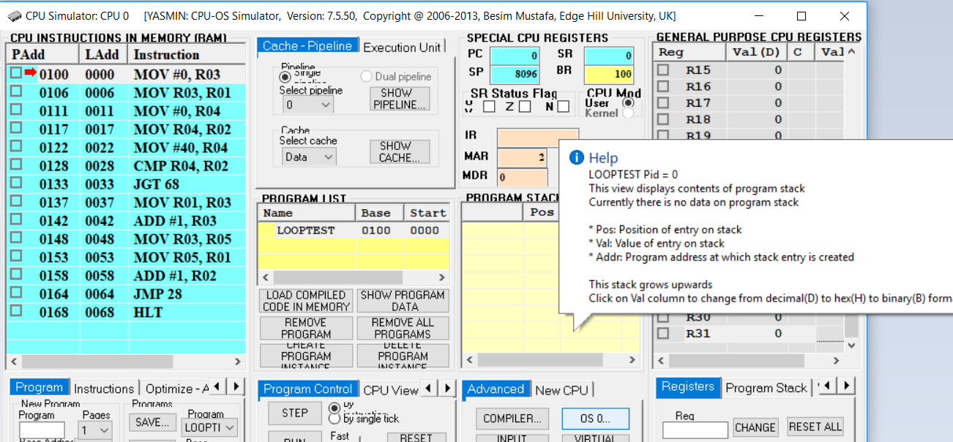 You should see an entry, titled LoopTest, in the PROGRAM LIST view. Now that this program is available to the OS simulator, we can create as many instances, i.e. processes, of it as we like. You do this by clicking on the CREATE NEW PROCESS button. Repeat this four times. Observe the four instances of the program being queued in the ready queue which is represented by the READY PROCESSES view.
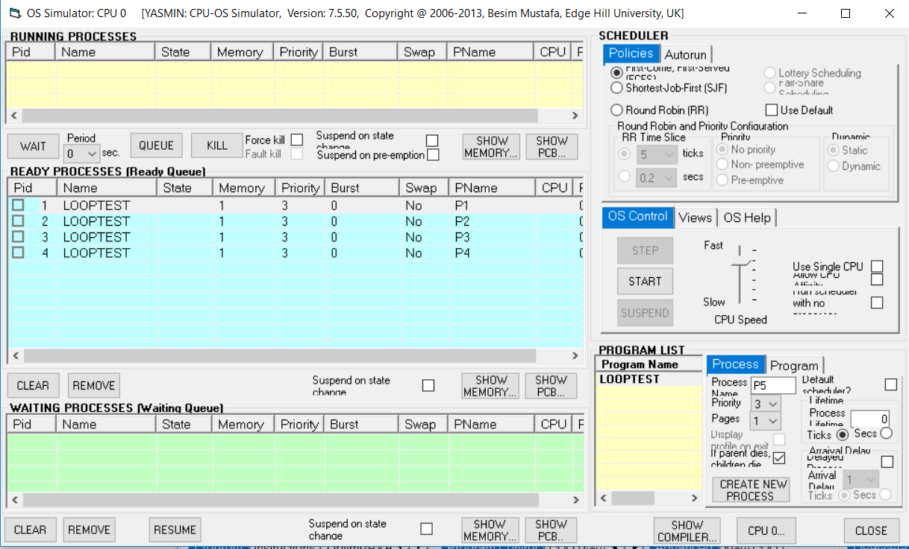
Now, it is very important that you follow the instructions below without any deviation. If you do, then you must re-do the exercise from the beginning as any follow-up action(s) may give the wrong results.
Step4 : Select different scheduling policies and run the processes in the OS simulator.
Make sure the First-Come-First-Served (FCFS) option is selected in the SCHEDULER/Policies view. At this point the OS is inactive. To activate, then click on the START button. This should start the OS simulator running the processes. Observe the instructions executing in the CPU simulator window. Concentrate on the two views: RUNNING PROCESSES and the READY PROCESSES during this period. You can view the process list as shown below:
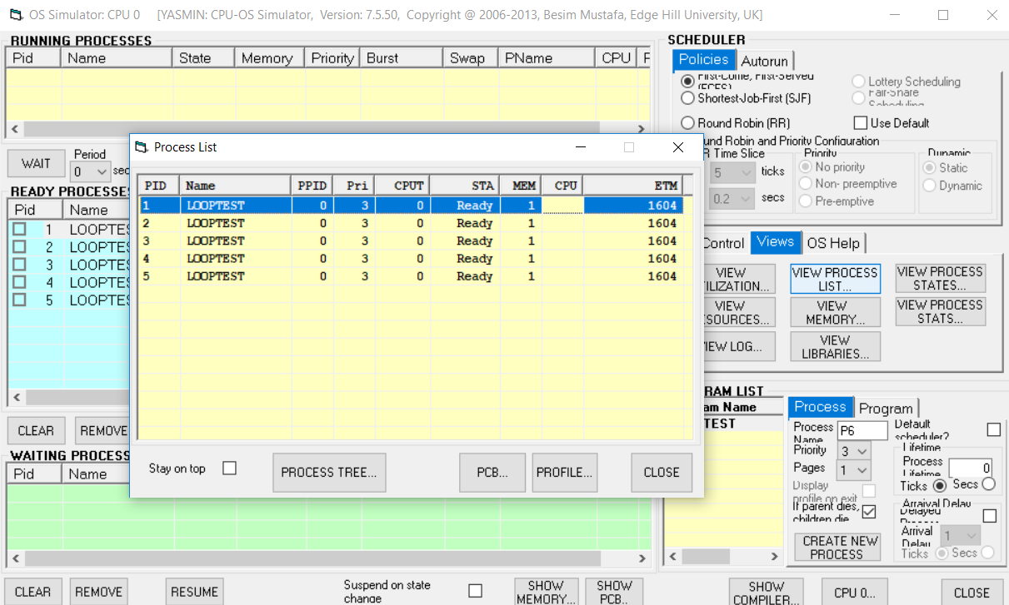

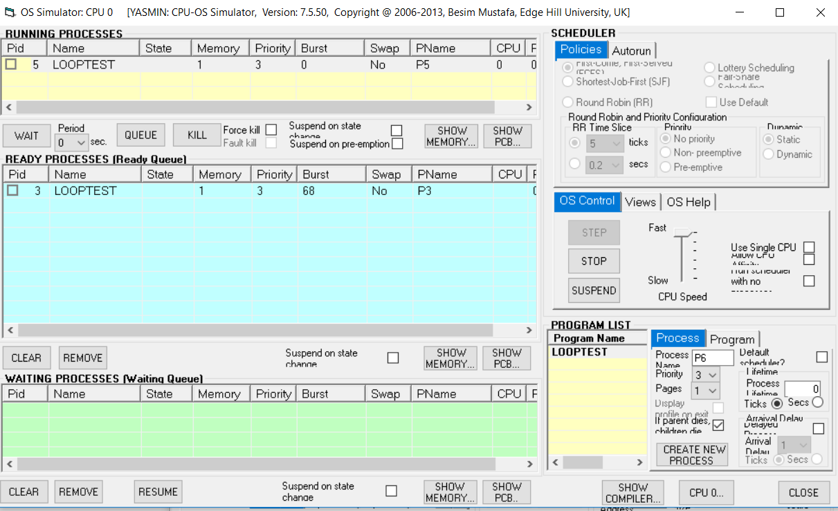

On the same lines select other scheduler policies and check for the output. The activity log can be viewed from views tab. The activity log for RR scheduling with three processes is as shown below:
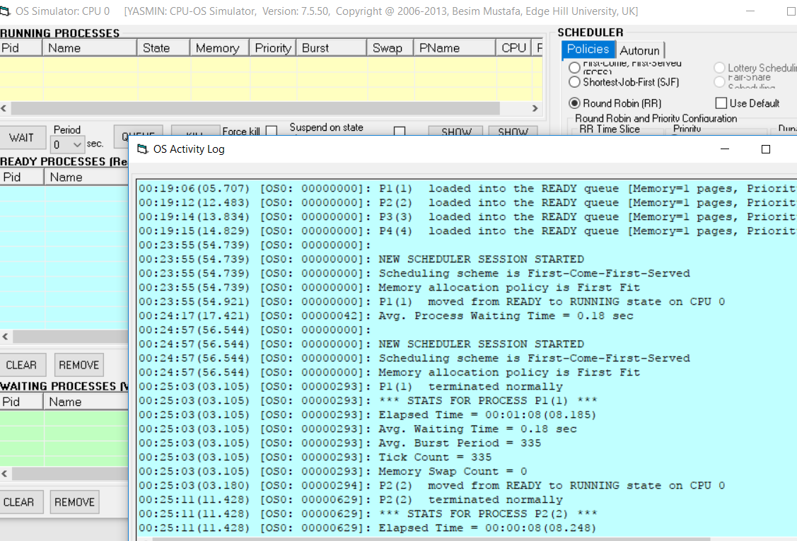

Experiment 2 Investigating the use of Threads
Follow the steps as in link //www.teach-sim.com/Operating systems-Investigating threads and synchronization.
Step1:Write a source code that creates threads. Start the CPU/OS simulator. In the compiler window enter the following source code:
program ThreadTest1
sub thread1 as thread
writeln("In thread1")
while true
wend
end sub

sub thread2 as thread
call thread1
writeln("In thread2")
while true
wend
end sub

call thread2
writeln("In main")

do loop
end
Step2 : Compile the source code to get the assembly code.
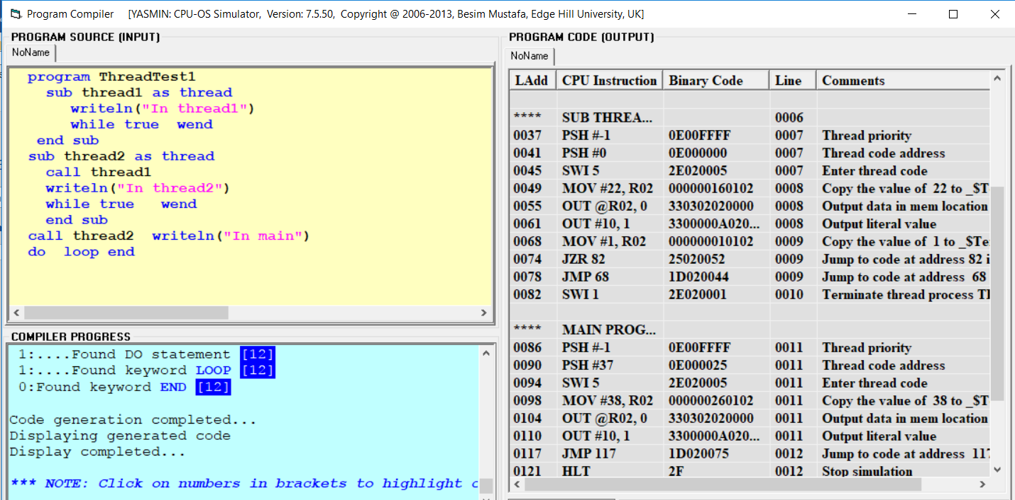

Step3: Load the code in the memory using load to memory.

Step4:Make the console window visible by clicking on the INPUT/OUTPUT… button. Also make sure the console window stays on top by checking the Stay on top check box.

Step5: Now, go to the OS simulator window (use the OS… button in the CPU simulator window) and create a single process of program ThreadTest1 in the program list view. For this use the CREATE NEW PROCESS button. Make sure the scheduling policy selected is Round Robin and that the simulation speed is set at maximum. Hit the START button and at the same time observe the displays on the console window as shown below:

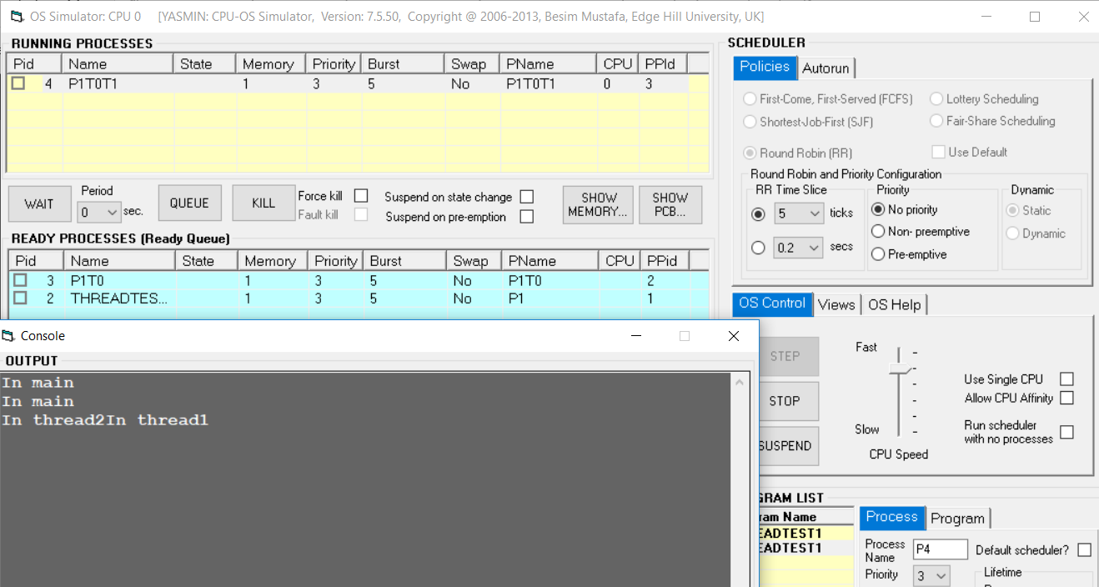

Experiment 3 Deadlocks Prevention

Four processes are running. They are called P1 to P4. There are also four resources available (only one instance of each). They are named R0 to R3. At some point of their existence each process allocates a different resource for use and holds it for itself forever. Later each of the processes request another one of the four resources. Draw the resource allocation graph for a four process deadlock condition.
Resource Allocation graph under consideration:
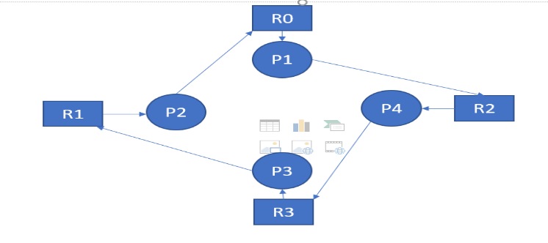

Step1:
In the compiler window, enter the following source code in the compiler source editor area (under PROGRAM SOURCE frame title).
program DeadlockPN
resource(X, allocate)
wait(3)
resource(Y, allocate)
for n = 1 to 20
next
end

The above code creates a program which attempts to allocate two resources for itself. After the first allocation it waits for 3 seconds and tries to allocate another resource. Finally it counts from 1 to 20 in a loop and then terminates. Other than that it does nothing sensible or useful.

Step2:
a. Copy the above code and paste it in three more edit windows so that you have a total of four pieces of source code.
b. In each case change N in the program name to 1 to 4, e.g. DeadlockP1, DeadlockP2, etc.
c. Look at your graph you constructed in (1) above and using that information fill in the values for each of the Xs and Ys in the four pieces of source code.
d. Compile each one of the four source code.
e. Load in memory the four pieces of code generated.
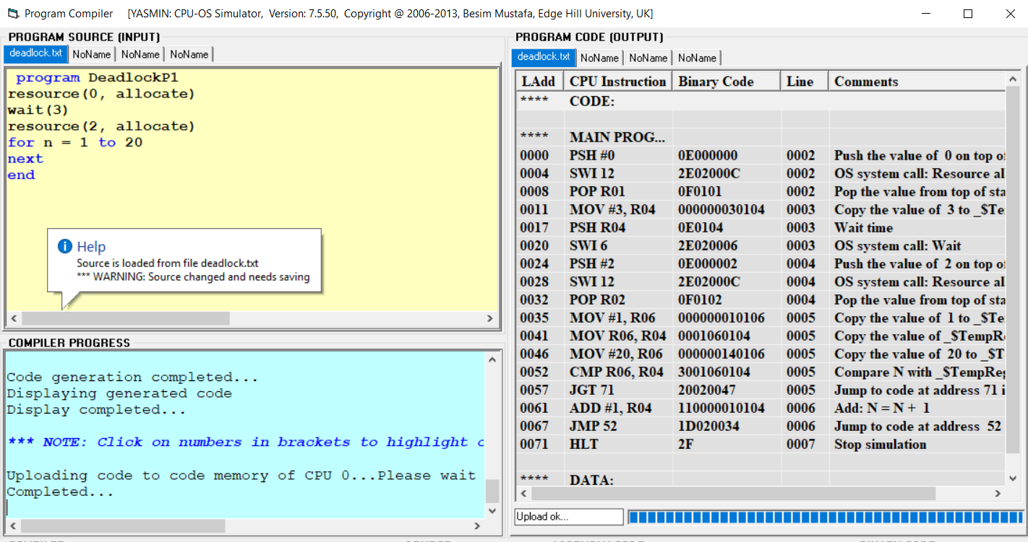
f. Now switch to the OS simulator.
g. Create a single instance of each of the programs. You can do this by double-clicking on each of the program names in the PROGRAM LIST frame under the Program Name column.
h. In the SCHEDULER frame select Round Robin (RR) scheduling policy in the Policies tab.
i. In OS Control tab, push the speed slider up to the fastest speed.
j. Select the Views tab and click on the VIEW RESOURCES… button.
k. Select Stay on top check box in the displayed window.
l. Back in the OS Control tab use the START button to start the OS scheduler and observe the changing process states for few seconds.
m. Have you got a deadlock condition same as you constructed in (1) above? If you haven’t then check and if necessary re-do above. Do not proceed to (n) or (3) below until you get a deadlock condition. n. If you have a deadlock condition then click on the SHOW DEADLOCKED PROCESSES… button in the System Resources
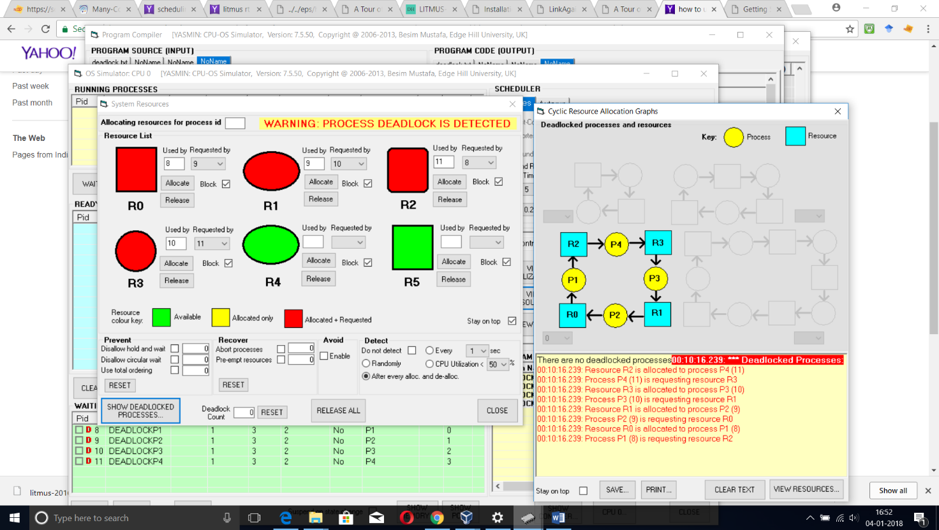

Step3: 3. Now that you created a deadlock condition let us try getting out of this condition:

a. In the System Resources window, there should be four resource shapes that are in red colour indicating they are both allocated to one process and requested by another.
b. Select one of these resources and click on the Release button next to it.
c. Observe what is happening to the processes in the OS Simulator window.
d. Is the deadlock situation resolved? Explain briefly why this helped resolve the deadlock.
e. Re-create the same deadlock condition (steps in 2 above should help).
f. Once the deadlock condition is obtained again do the following: In the OS Simulator window, select a process in the waiting queue in the WAITING PROCESSES frame.
g. Click on the REMOVE button and observe the processes.
h. Has this managed to resolve the deadlock.

